Eat Right for Resistance Training

# Fueling your workout:

# Proper nutrition is important for athletes to improve overall performance and increase muscle strength.

So what is important for athletes?

**Adequate Energy**

Your energy needs change based on how often and how hard you train. When training in resistance exercise, take care to consume a diet that contains high-quality protein and adequate carbohydrate and heart-healthy fat sources. While eating enough protein is critical to building and repairing muscle, protein is used only as a minor energy source during exercise.

**Carbohydrates**

Carbohydrates provide energy so your body does not have to use protein as a fuel source. Getting enough carbohydrates can prevent early fatigue and injury.

Good sources of carbohydrates include:

* Whole grains like whole-wheat breads and pastas, brown rice and quinoa
* 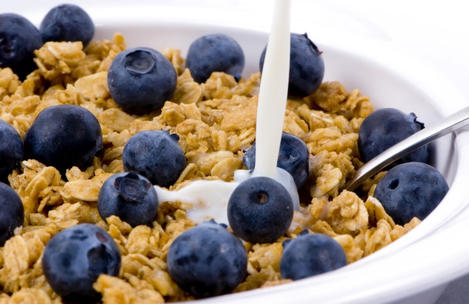Fruit
* Dairy
* Energy bars
* Sports drinks

Fat

When performing a high intensity, high power resistance exercise, fat is not used as a fuel source. Even so, fat is an essential macronutrient. It aids your body in many ways, including providing energy for low- to moderate intensity exercise and insulating your organs. Aim for a diet containing 20 percent to 35 percent of energy from fat. Very low-fat diets are not recommended because they can lead to a shortage of some nutrients and can hurt your performance.

Healthy sources include:

* Fish
* Nuts
* Nut oils
* Seeds
* Vegetable oils and spreads made from a vegetable-oil base

**Protein**

Resistance training requires muscle strength and power. Protein plays an important role in building and maintaining muscle. It also promotes healthy immune function. While the protein needs of athletes are highly debated, most researchers agree resistance-trained athletes need more protein than the general population.

Good sources of protein include:

* Lean meat, poultry and fish
* Fat-free or low-fat milk, yogurt and cheese
* Eggs
* Legumes (lentils, black beans, pinto beans, dried peas)
* Soy products

**Need an example of protein requirements?**

A 150-pound individual needs approximately 81 to 116 grams of protein per day. A typical day that includes three servings of low-fat or fat-free dairy plus three servings of protein foods (such as lean meat, poultry, fish or beans) will provide quality sources of protein to help reach that goal. Grains, especially whole grains, also provide some protein.

The following foods provide a total of 90 grams of protein:

2 cups fat-free milk = 16 grams

8 ounces plain low-fat yogurt = 12 grams

1 tablespoon peanut butter = 7 grams

3 ounces baked chicken = 26 grams

3 ounces grilled salmon = 21 grams

1 cup quinoa = 8 grams

Adapted from: The Academy of Nutrition and Dietetics (2014)

http://www.eatright.org/Public/content.aspx?id=7086